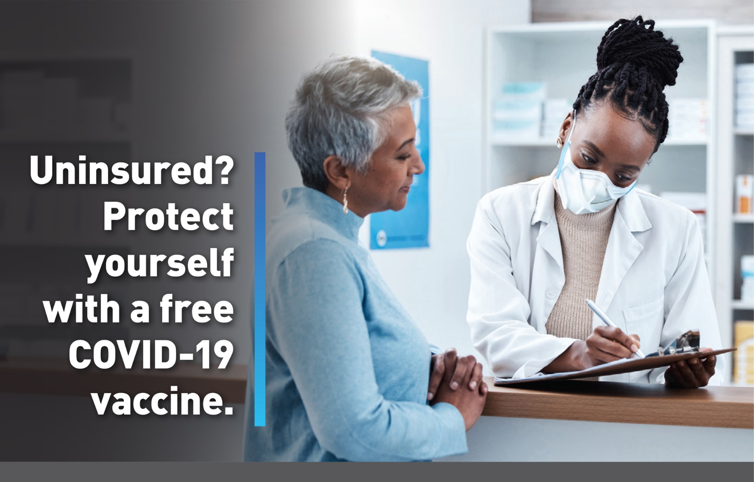
If you are 18 years or older and uninsured, or your health insurance plan doesn’t fully cover COVID-19 vaccination, you can get a free COVID-19 vaccine through the Bridge Access Program. Join us at Click or tap here to enter text. (e.g., Bridge Access Program vaccine clinic or health fair/event) to Click or tap here to enter text. (e.g., learn more and get vaccinated!) |  | Date Click or tap here to enter text.  Time Click or tap here to enter text.  Location Click or tap here to enter text.
 |  |  | 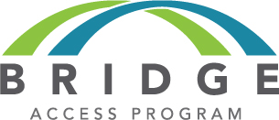
 |  |  | 

